# Assignment Module 2 Description

*By Michael Floerchinger*

05/17/2017

Java III Programming

Assignment #2

Project Change Description

Replace the “View” component of your application with a new view. The new view will make use of Java Swing library classes or SWT.

You must design a GUI that supports the functionality of the previous “View” component. The new “View” component will

interface with the “Model” component in the same manner as the previous “View” component.

**Deliverables**

There are two deliverables that must be submitted. These deliverables are as follows:

1. Your source code in a .jar or .zip file format.

2. Captured images of your application in operation.

# Deliverables

## **Images of Application Execution and Functionality**

### **Overview**

Application Assignment 2 is the implementation of a GUI view using the Java Swing and AWT libraries. The application provides a GUI interface to the inventory program assignment for Assignment 1. This assignment requires only the UI replace the view component for the previous MVC architecture. The View component interfaces to the existing controller interface, and no changes were implemented throughout the rest of the application to support these changes. The view implements all the Java Swing and AWT libraries, the GUI frame and interface components and the action listener interfaces.

1. ***Application Startup***

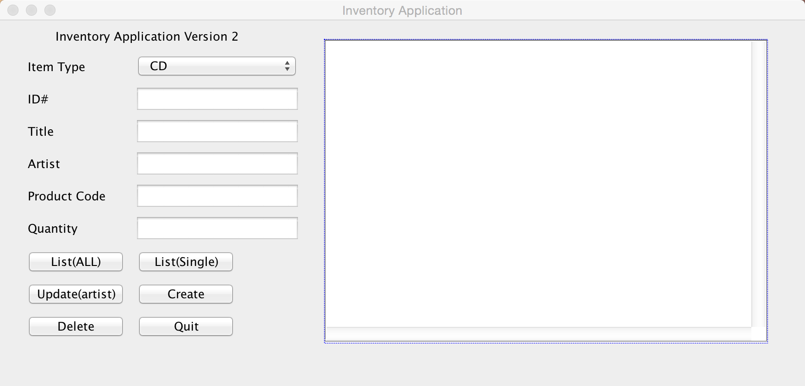

Application on startup. The application provides a GUI interface to the inventory program assignment for module 1.

1. ***List All Inventory Items***

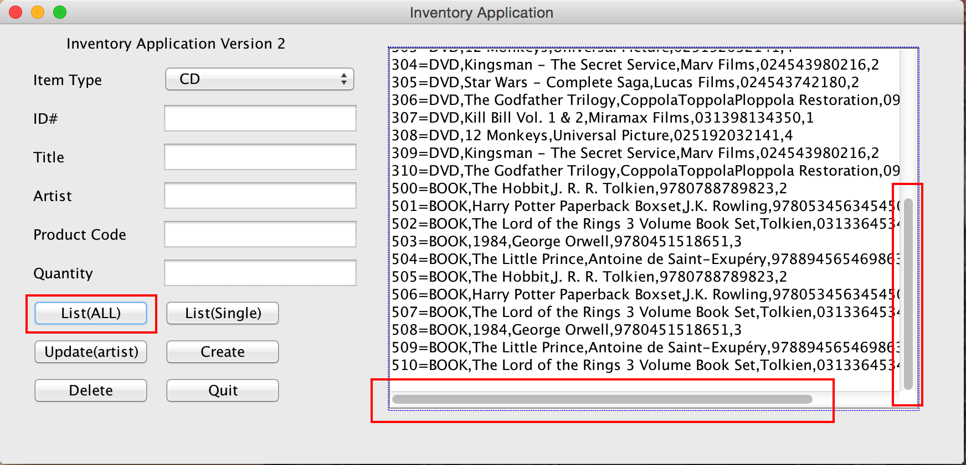

Selecting the “List(All)” button returns the entire list of inventory items. The inventory list was increased in size in order to be able to demonstrate the “scrollpane” view for both vertical and horizontal view scrolling.

1. ***List Single Inventory Item***

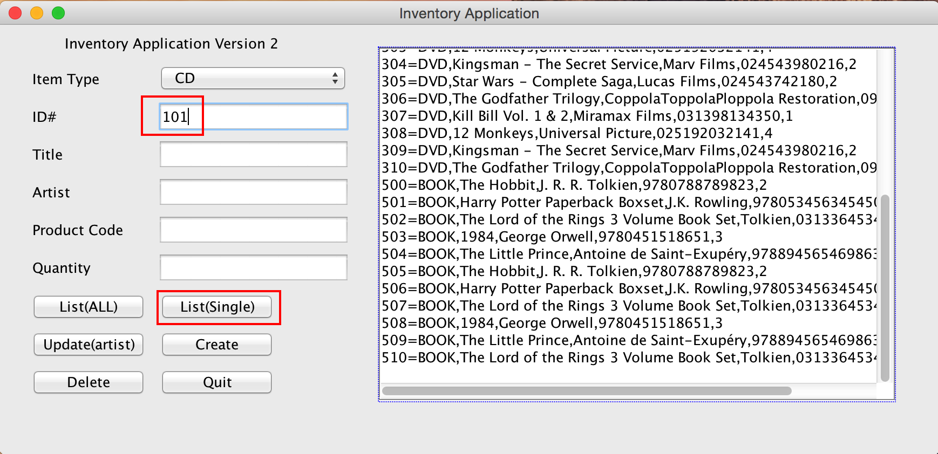

The “List(Single)” view provides the ability to view a single row element. This can be achieved by selecting an inventory ID# number from the view screen and inserting it into the ID# field,

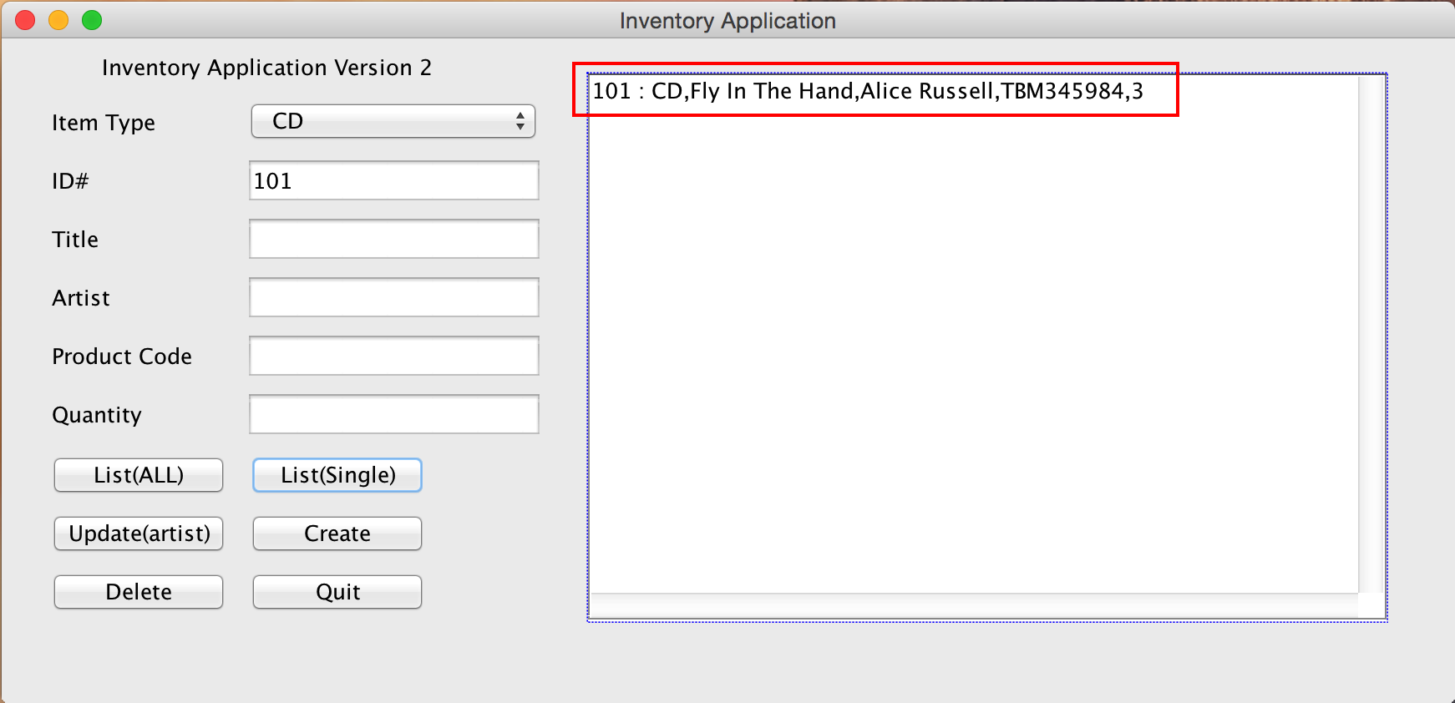

By clicking the “List(Single)” button, returns to the user the Single row inventory element.

1. ***Update Record, (Artist Only)***

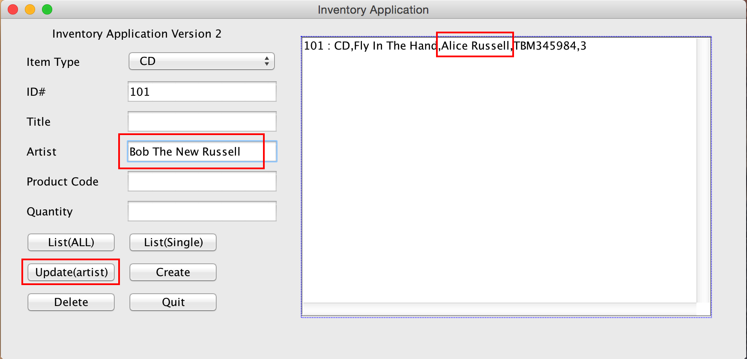

By using the previous example demonstrated above, the “Update(artist)” button allows us to update the artist name for the presented inventory item. NOTE: The previous assignment only updated the artist name for an inventory record, and as such no application functional changed were implemented for assignment2.

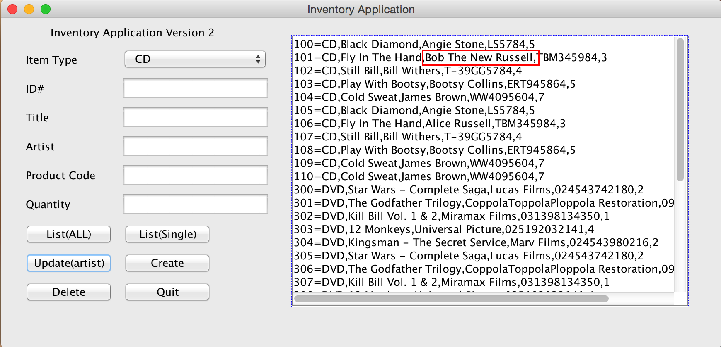

Updating the artist name for ID# 101 shows artist name changed from ***Alice Russell***, to ***Bob The New Russell***

1. ***Create New Inventory Item***

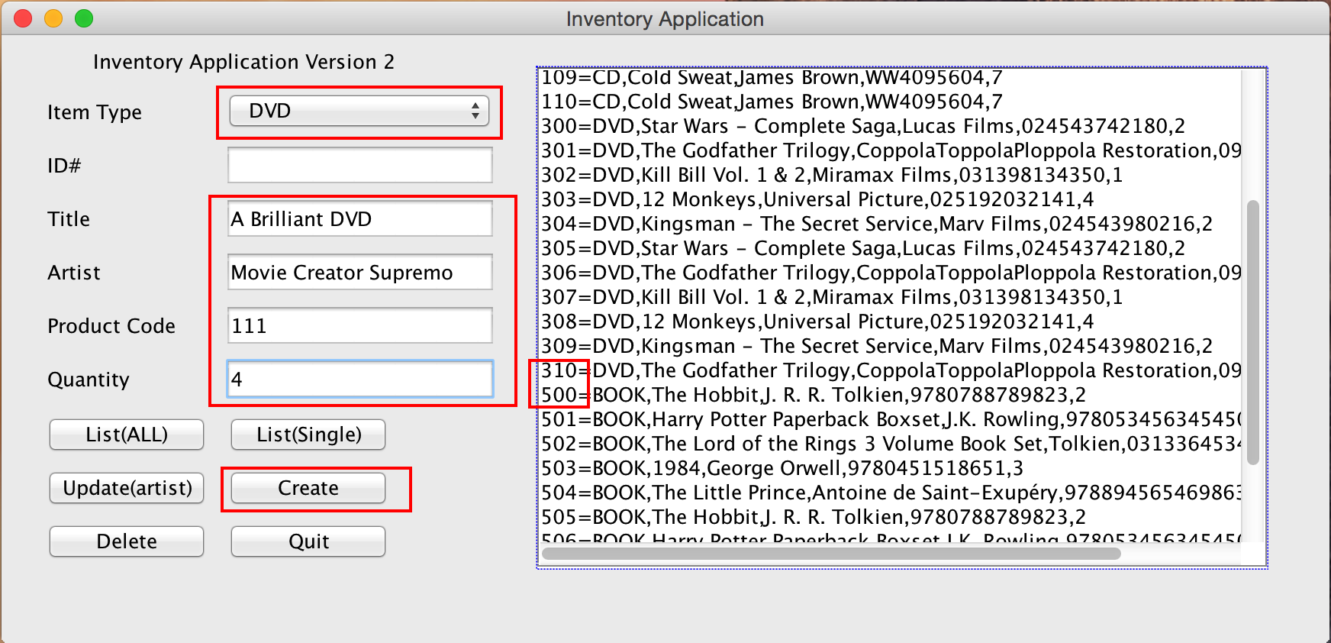

The above screenshot shows creating a new inventory item. The comboBox provides for selecting inventory type item, CD, DVD, BOOK. User enters the details of the record to be added. The right side screen shows the current record numbers for all the inventory items. Selecting the drop down itemType selector automatically selects the next item number available for a particular itemType. Clicking the “Create” button creates the next record.

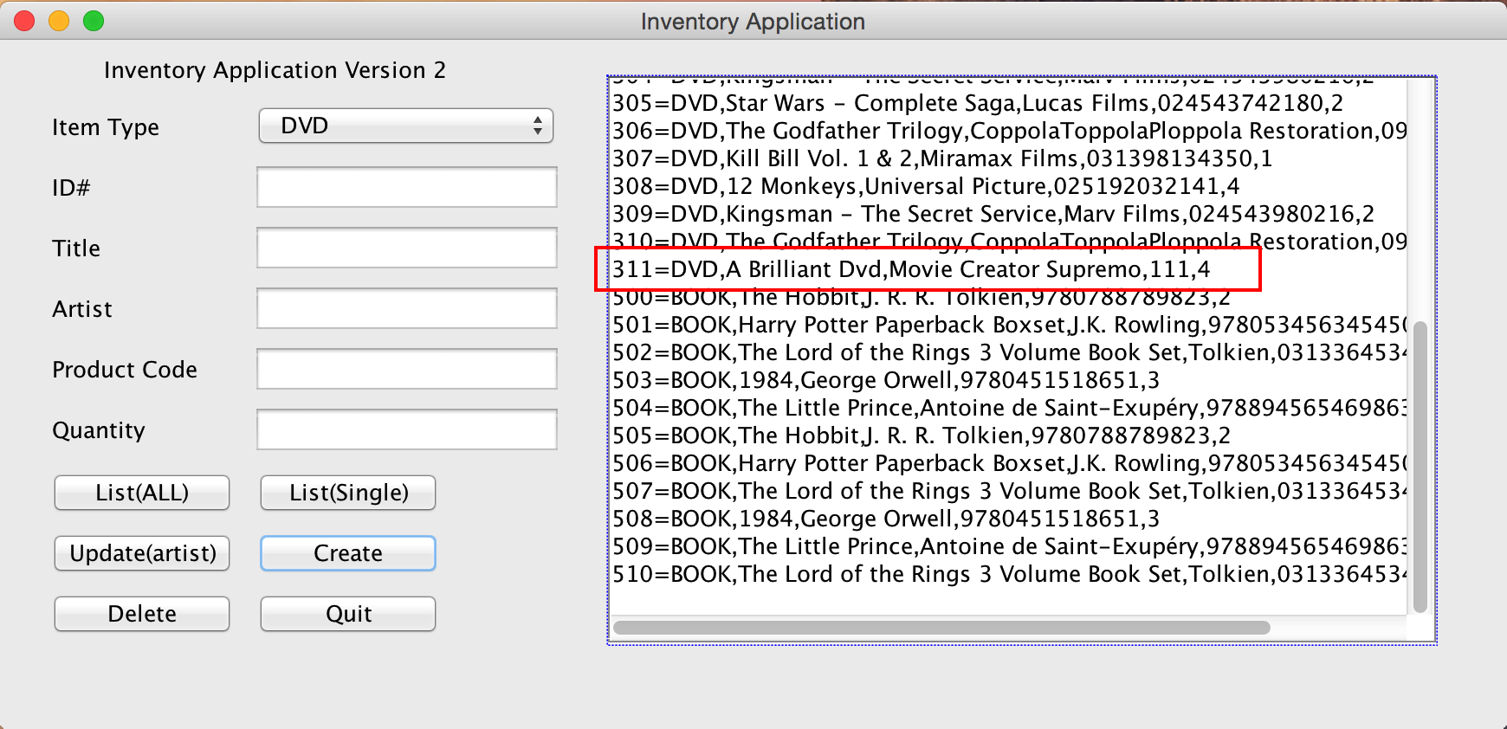

The above screenshot shows the new inventory item, with the next consecutive DVD itemType number, 311. Also the input fields were cleared allowing for the next record to be created.

1. ***Delete Inventory Item***

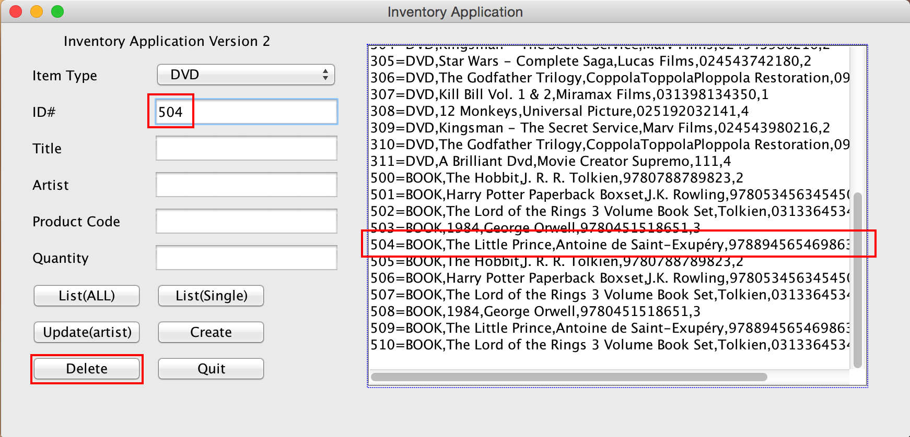

The “Delete” buttons enables the deletion of items from the inventory. By selecting an unwanted item number from the view, a user is able to delete a particular ID#, by submitting that number into the ID# field and clicking the “Delete” button.

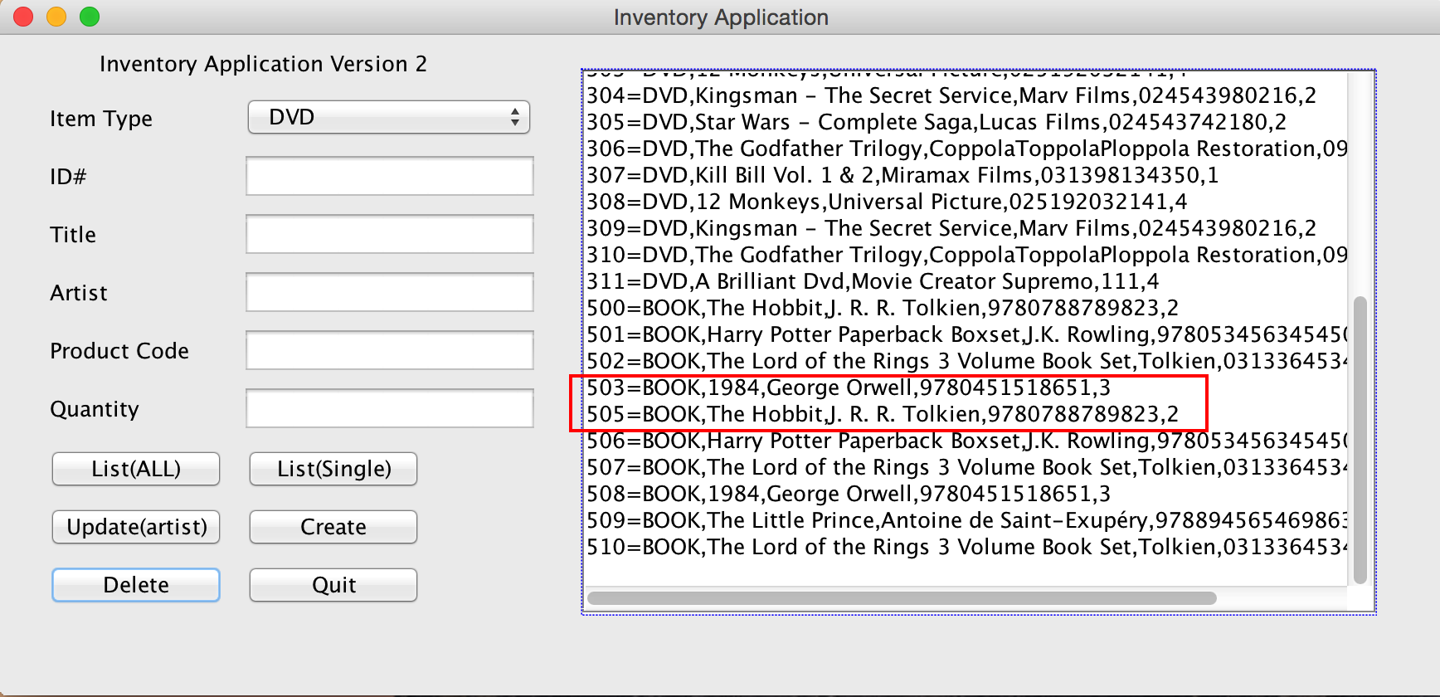

Screenshot above shows item 504 deleted and no longer available.

1. ***Quit Application***

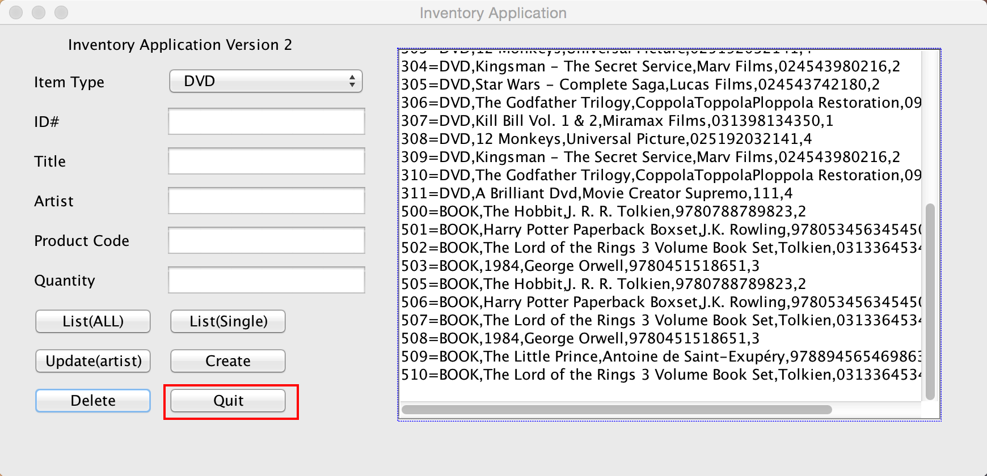

To exit the application, click the “Quit” button.